1. Print all processes in the system

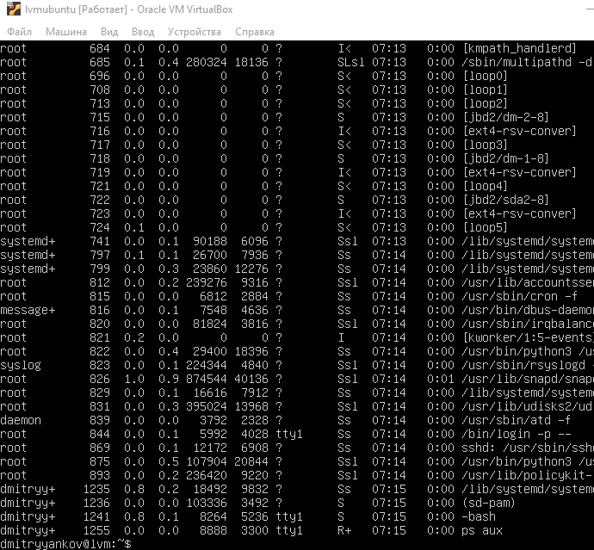

1. Print only your user’s processes

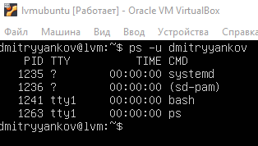

1. Run top in the background



1. Stop the top process running in the background



1. Stop all processes running right now from the current user
2. Run the ping process (against 8.8.8.8 server) in the dedicated screen (using screen command). Demonstrate switching from one screen to another 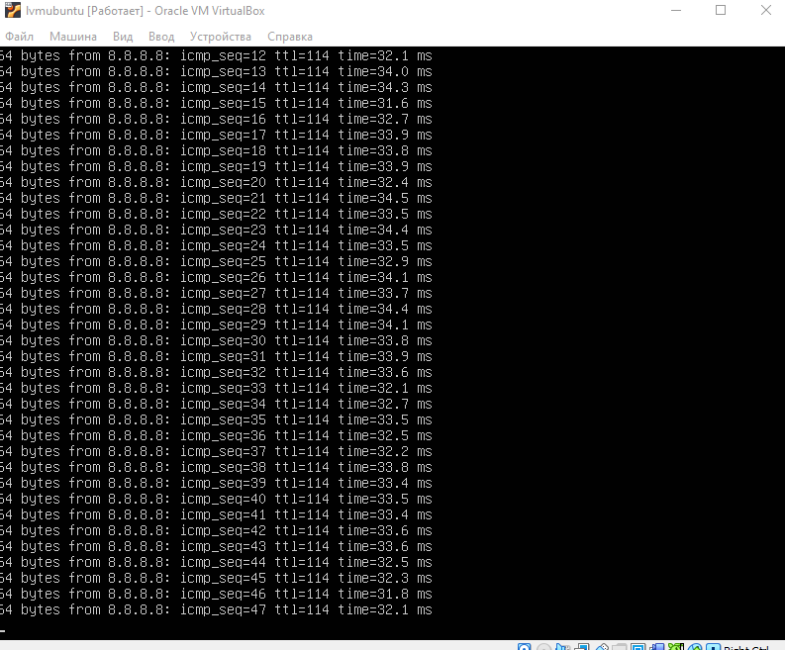 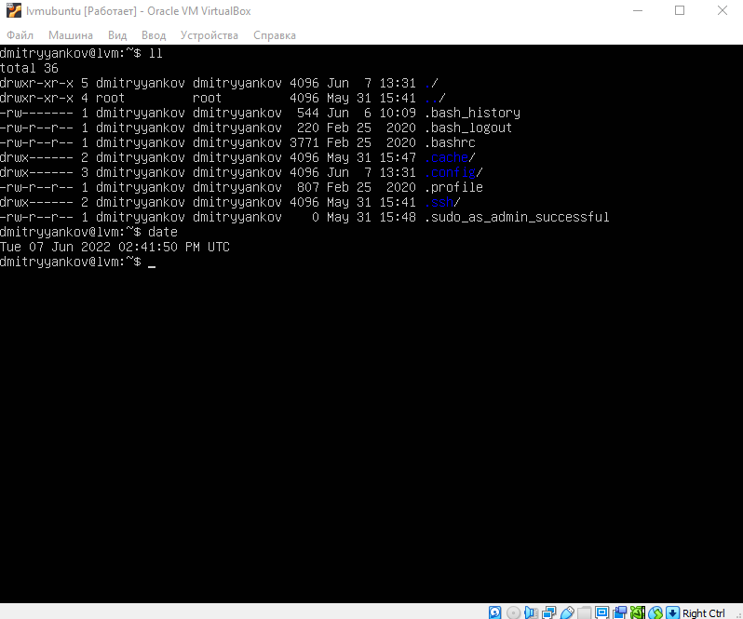
3. Create some systemd service which will log something to a file

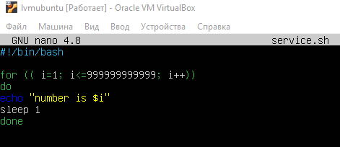

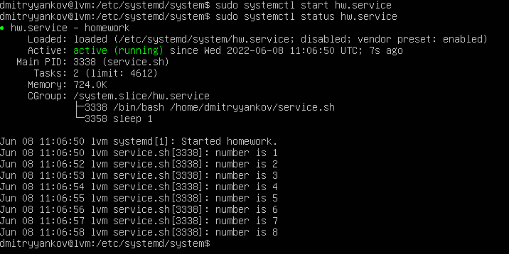

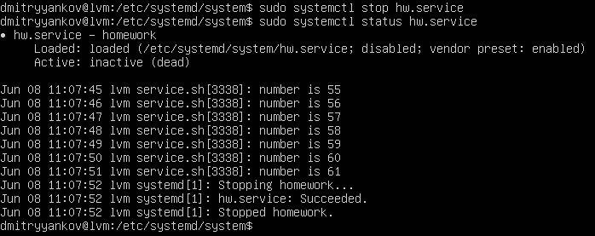

1. Create a cron task which will write the timestamp to some file once in 10 minutes.

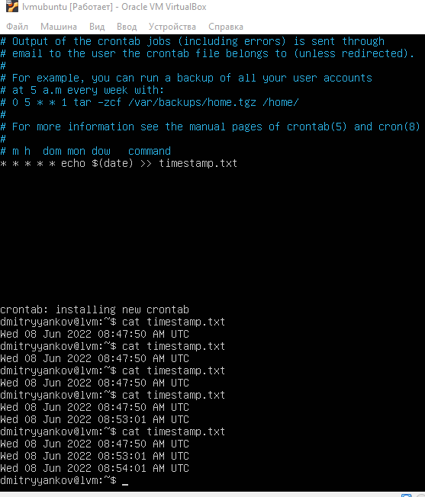

1. Actions №1-5 should be a part of the shell (bash) script and can be executed on the EMPTY system without errors

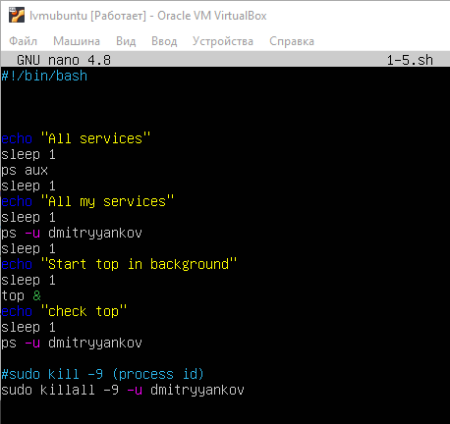

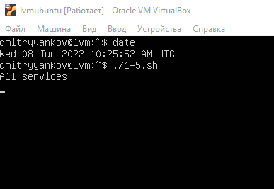

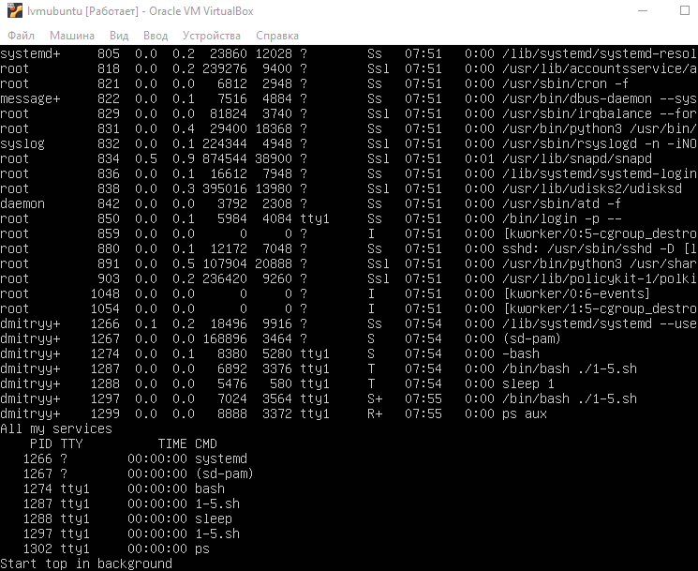

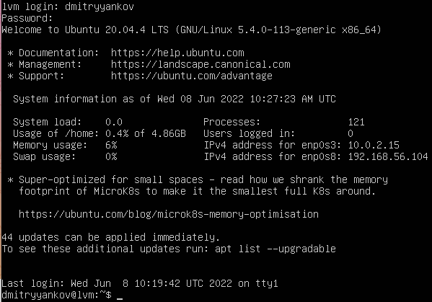

Send screenshots for each step

Send script for a review

Send a proof that this script works on the fresh and empty system.